Step 1: Join the informational Zoom session at 6:30pm (ALL students and families should attend)
- Zoom Link
  - https://hallco.zoom.us/j/96967934534
  - Password- EHHSBAND (ALL CAPS)
- More information will be share about:
  - Marching Band Information
  - Band Camp 2020
  - Percussion/Color Guard/Leadership auditions
  - Signing up for your CHARMS account

Step 2: Fill out the 2020 Viking Band Interest Form
- Follow the link to fill out the Viking Band Interest Form- https://forms.gle/ioxe1YJaX6sBTE158
- This form will help us determine how many students plan to participate in our band program next year!

Step 3: Join the band Remind group!
- This is a very important step. Remind is the primary method of communication between the director and students/families. PLEASE make sure the sign up!
- Text @ehband2020 to 81010
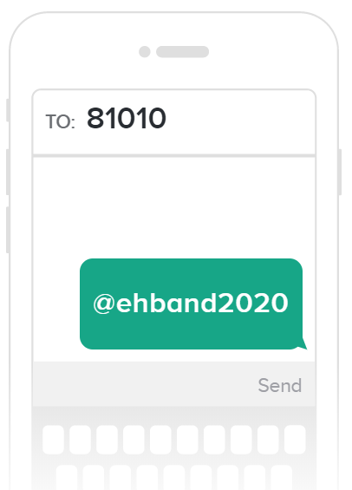

Step 4: Sign up for your CHARMS account
- The Viking Band is transitioning to an online office assistant called CHARMS to better organize our band program information. Parents and students will be able to access their CHARMS account 24/7 and use features such a viewing and paying their band account balance, volunteering for band events, communicating with other band parents and much more!
- Follow the instructions below to create your student’s band account!

Creating your student’s CHARMS Account
- Go to https://www.charmsoffice.com/
- Click on the LOGIN button (upper right corner)
- Enter EastHallBand as the school code
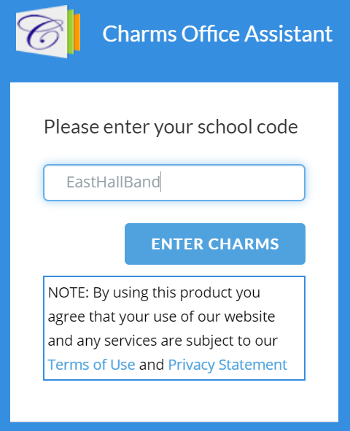
- Enter your student’s school ID number to login
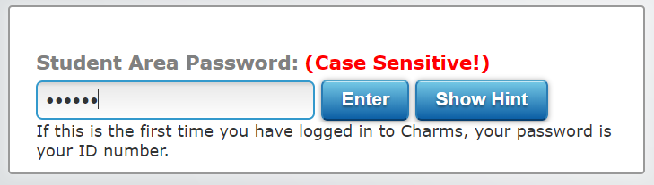

- You will then change your password. Make sure it it something you can remember!
- Click on the student information icon

- Fill out your student information
- Click on the Add New Adult button at the bottom.
  - Be sure to check the interests/skills box!
- Be sure to click on the GREEN update button to save your information
- Your CHARMS profile is now complete! More information will be added to your students profile in the next few weeks. You can access the profile 24/7!

Step 5: Visit www.ehhsband.com for more information on the East Hall High School Viking Band Program. You may also email EHHS Director of Bands, Adam Youngman, if you have any questions.
- (adam.youngman@hallco.org)

Step 6: Pay your Marching Band Registration Fee ($100)
- Please visit “our programs” on our website for more information on Marching Band dues and fees. The marching band registration fee is due on April 21st, 2020.
- Parents and families can pay this fee using the PayPal link on the home page of our band website.
- We understand that the current global pandemic and economic crisis has put many of our families in difficult financial situation. If you cannot pay the marching band registration fee at this time, THAT IS OK. Please do not let that keep a student from registering for band. The registration fee allows us to begin the season with funds to pay for show design, band camp staff, maintenance and upgrades to instruments, and more. If you are able to pay the registration fee, please use the PayPal link provided on the website.

