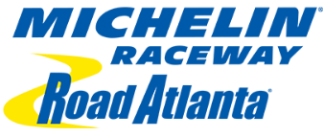
WE NEED YOU
Michelin Raceway Road Atlanta
5300 Winder Hwy Braselton, GA 30517

Wednesday October 14 7:00AM / Until TBD
Thursday October 15 7:00AM / Until TBD
Friday October 16 6:30AM / Until TBD
Saturday October 17 6:00AM / Until TBD

This is a great opportunity to help pay for the upcoming band dues.
If you are interested in working please contact Jacob Skinner at
770-561-8216 by text or call, you can e-mail
jacob.skinner@ekgsecurity.com
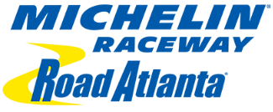
When reporting to work, enter at the main gate. They will direct you to the EKG SERVICES sign in area.

Please wear white or tan pants or shorts. No open toe shoes or unapproved caps. We will supply an event t-shirt and cap. All t-shirts must be turned back in on your last day of work. We will also supply a jacket if it is cold. The jacket will need to be returned as well.

Bring with you food, or money for food, and sunscreen. We will supply bottled water.

If you are with one of the high schools or volunteer groups, please make sure you sign in and out on your groups list. If you are not with one of the high schools or volunteer groups, you will need to complete a time sheet. Make sure you turn in the time sheet before you leave the track on your final day.

Thank you!!

Ken Grogan 404-787-6862

Jacob Skinner 770-561-8216

