Step 1: Stop by the band room any time between 4:00-7:30pm on 5/18/21 (ALL band students and families)

Step 2: Join the band 2021-2022 Viking Band Remind group!
- This is a very important step. Remind is the primary method of communication between the director and students/families. PLEASE make sure to sign up!
- Text @ehband21 to 81010
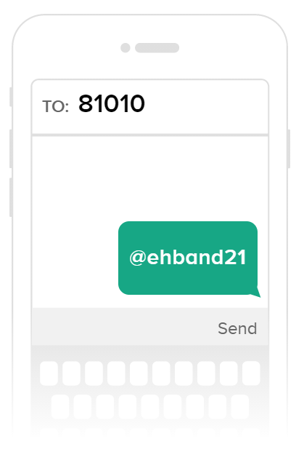

Step 3: Sign up for your CHARMS account (LOGIN if returning member)
- The Viking Band uses an online office assistant called CHARMS to better organize our band program information. Parents and students are able to access their CHARMS account 24/7 and use features such as viewing and paying their band account balance, volunteering for band events, communicating with other band parents and much more!
- Follow the instructions below to create your student’s band account!

Creating your student’s CHARMS Account
- Go to https://www.charmsoffice.com/

- Click on the LOGIN button (upper right corner)

- Enter EastHallBand as the school code
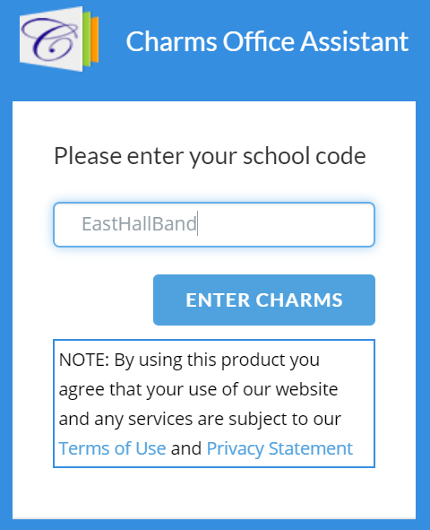

- Enter your student’s school ID number to login
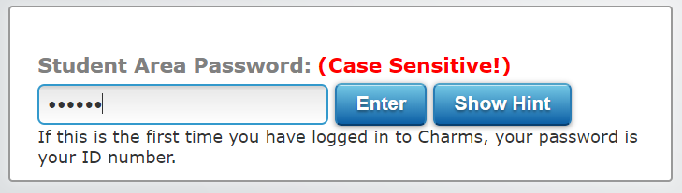

- You will then change your password. Make sure it is something you can remember!

- Click on the student information icon
- Fill out your student information

- Click on the Add New Adult button at the bottom.
  - Be sure to check the interests/skills box!
- Be sure to click on the GREEN update button to save your information

- Your CHARMS profile is now complete! More information will be added to your students profile in the next few weeks. You can access the profile 24/7!
Step 4: Pay your Marching Band Registration Fee ($100)
- Go to www.ehhsband.com
- Please visit “our programs” on our website for more information on Marching Band dues and fees. The marching band registration fee is due on May 18, 2021.
- Parents and families can pay this fee using the PayPal link on the home page of our band website.
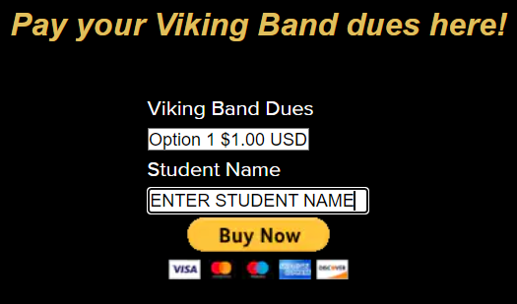 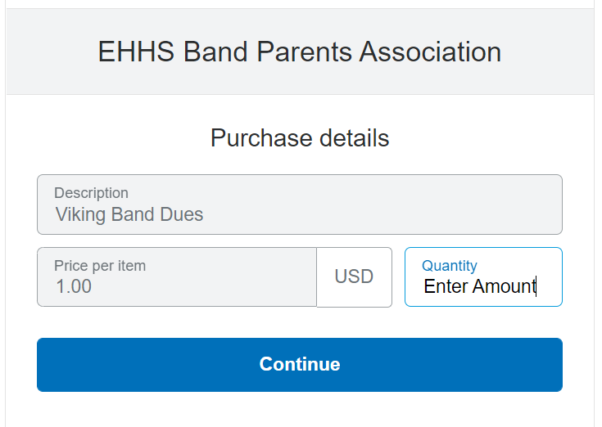
- Using the PayPal button on the band website
  - Enter Student Name- CLICK Buy Now
  - Enter amount you would like to pay in the QUANTITY section
    - Example- enter 100 if paying $100
  - Click continue to pay with debit or credit card. Funds are immediately credited to your student’s band account

Thank you for registering to be a part of the 2021-2022 Viking Band Program! More information about all aspects of our band program can be found at www.ehhsband.com. We are looking forward to an incredible 2021-2022 school year!

Thank you!

Adam Youngman
Director of Bands
adam.youngman@hallco.org

